**How Does a Tree Grow?**

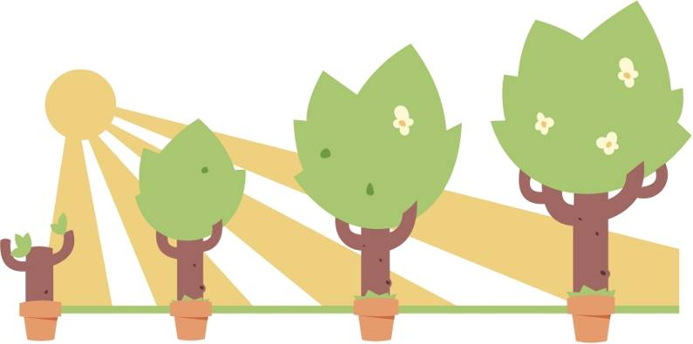

In 1634, a scientist named Jan Baptist Van Helmont questioned how it was that plants grew. He wondered if plants got the nutrients that they needed from the soil, so he planted a small willow tree in a tub of dry soil. Before planting, he weighed the tree and soil separately. The tree weighed 5 pounds and the soil weighed 200 pounds. Over the next 5 years he gave the tree nothing but rainwater to keep it alive. After 5 years, he dug up the tree and again weighed the tree and soil separately. The tree now weighed 169 pounds and the soil weighed 199.8 pounds. Van Helmont concluded that “164 pounds of wood, bark, and roots came from the water only.”

What was the change in the mass of the tree? Show your work below.  
  
  
  
  
What was the change in the mass of the soil? Show your work below.  
  
  
  
  
What did Van Helmont conclude from his experiment?  
  
  
  
  
  
Do you agree with his conclusion?

A class was asked whether they agreed with Van Helmont. Here are some of their responses:

**Jake**: *I think the tree grew from minerals in the soil.*  
**Amy**: *I think that plants make their food from sunlight.*  
  
**Steve:** *I agree with Van Helmont. Only the water could have made this much difference.*  
  
**Nicole:** *I think that plants grow and expand because of the gases in the air.*

Which student do you agree with most? Don’t worry about being wrong – pick the one that you think best explains how plants grow! Write the name of the student you agree with below and a brief explanation of why.  
  
_________________________________________________________________________________________________________

_________________________________________________________________________________________________________

_________________________________________________________________________________________________________

_________________________________________________________________________________________________________

_______________________________________________________________________________________________________

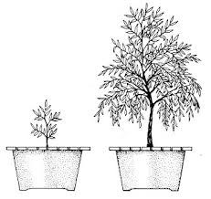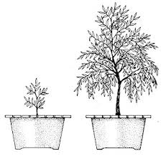

**Soil**

*Pick one person in your group to be the recorder. As a group, discuss the questions below. The recorder should write down the various answers that are discussed on a separate sheet of paper.*

1. What is soil made from?
2. How much did the mass of the soil decrease over the five years? Could this have contributed to the growth of the plant? How much?
3. Can plants grow without soil?

*Look at the results of the investigation below on mung beans. Mung bean seeds were germinated and grown in two solutions - one containing all the minerals found in soil, one with just water (no minerals)*

Water only Water + Minerals

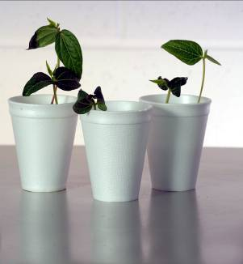 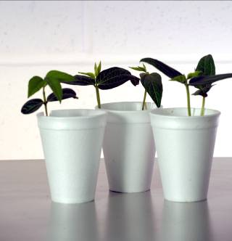

1. Can plants grow without minerals?
2. Do minerals have an effect?
3. Do you think it is correct to say that some of the tree came from minerals in the soil?
4. How much could the minerals have contributed to growth?

**Sunlight**

*Pick one person in your group to be the recorder. As a group, discuss the questions below. The recorder should write down the various answers that are discussed on a separate sheet of paper.*

1. What is sunlight?
2. Does sunlight have mass?
3. Living things are made of atoms. Are there any atoms in sunlight?
4. Could sunlight contribute to the increase in mass of the plant?
5. Is sunlight needed for plants to grow? What role do you think it might have?
6. Do you think it is correct to say that plants make their food from sunlight? Try to summarize your thoughts using some of the points above to support your argument.

**Water**

*Pick one person in your group to be the recorder. As a group, discuss the questions below. The recorder should write down the various answers that are discussed on a separate sheet of paper.*

1. Is water a food source?
2. Could you survive on water alone? Explain why or why not.
3. Do we know how much water was added to the pot over the five years?
4. What should Van Helmont have done if he had wanted to prove that all this increase in mass was from water?
5. What measurements could he have taken?
6. Do you think Van Helmont was correct to say that water alone accounted for the growth of the willow tree? Try to summarize your thoughts using some of the points above to support your argument.

**Gases**

1. What gases are in the air?
2. Do the gases in the air have mass? (If you compare and empty balloon and one filled with air you will soon find out.)
3. How could you show that these gases have an effect on increasing the mass of a plant?

*Look at the results of an experiment that examined the growth of plants at three different concentrations of carbon dioxide (ppm =parts per million)*



1. What does the data tell you?
2. Can gases in the air affect growth?
3. Which gas is shown to have an effect in these experiments?