Taxonomy Review
Use the diagram below to help answer the questions.
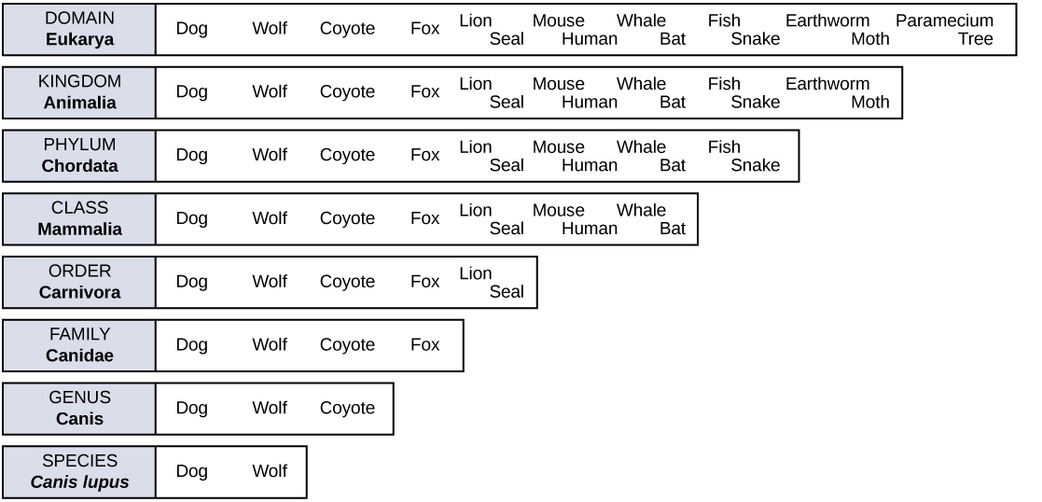
- Which taxon group has the most variation in organisms? _______________________________
- Which taxon group has the least variation in organisms? _______________________________
- Which taxon group is the most inclusive? _______________________________
- Which taxon group is the most specific? _______________________________
- If two organisms belong to the same order, what other taxonomic groups must they also belong to?
_____________________________________________________________________________________________

- Who is more related? The fox and the lion or the fox and the coyote?

_____________________________________________________________________________________________
- According to this diagram, could a dog and wolf breed and produce fertile offspring? Why or why not?

_____________________________________________________________________________________________
_____________________________________________________________________________________________

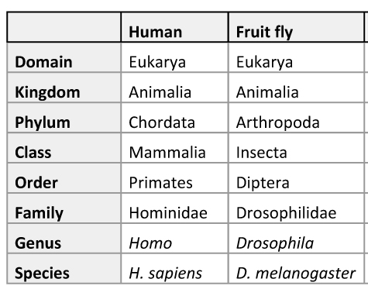

- What are two ways that humans and fruit flies are similar?
_____________________________________________________________________________________________

_____________________________________________________________________________________________
- At which taxonomic group do humans and fruit flies separate? _________________________
- What is the genus of the fruit fly? __________________________________________________________
- What is the species of the fruit fly? _________________________________________________________
- What is the scientific name of the fruit fly? ________________________________________________
- What is the scientific name of humans? ___________________________________________________

