Photosynthesis/Cellular Respiration/Fermentation Breakdown
*Required Biology Homework*

Purpose
- The purpose of photosynthesis is __________________________________________________________
_________________________________________________________________________________________________

- The purpose of cellular respiration is _____________________________________________________
_________________________________________________________________________________________________
- The purpose of fermentation is ____________________________________________________________
_________________________________________________________________________________________________

Reactants and Products
Process | Reactants | Products
Photosynthesis
Cellular Respiration
Alcoholic Fermentation
Lactic Acid Fermentation

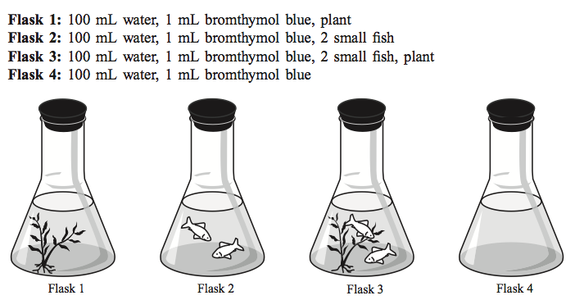

A class set up an experiment with the four flasks above. Each flask had a stopper and was put under a light. What color should the solution in each flask be?
 | Original color | Color after a few hours? | Explanation
Flask 1
Flask 2
Flask 3
Flask 4
Cycles of Matter

The Water Cycle
Enters the Atmosphere
Returns to Earth
How it’s stored on Earth

The Carbon Cycle
Enters the Atmosphere
Removed from the Atmosphere/ Returns to Earth
How it’s stored on Earth

