Photosynthesis & Cellular Respiration and Cycles of Matter Review

- Define the following:
  - Heterotroph

  - Autotroph

  - Photosynthesis

  - Cellular respiration

  - Fermentation

  - Evaporation

  - Transpiration

- Where does all of the energy needed by living things originally come from?

- What molecule provides energy for most cell activities? ___________

- What is a reactant?

- What is a product?

- What are the reactants and products for photosynthesis?

- What are the reactants and products for cellular respiration?

- What type of organism(s) does photosynthesis occur in? _______________________

- What organelle does photosynthesis occur in? _____________________________

- How are photosynthesis and cellular respiration similar? (Give 2-3 reasons)

- How are photosynthesis and cellular respiration different? (Give 2-3 reasons)

- How do plants use the sugar produced during photosynthesis?

- What would happen to the amount of sugar a plant makes if the amount of carbon dioxide were reduced?

- If you were to set up an experiment testing the color of light on plant growth, what would be the best set up?

- Using your knowledge of light, energy, and plants, explain why the following statement is incorrect, “Plants are green and therefore grow best under green light.”

- What type of organism(s) does cellular respiration occur in? ___________________

- What organelle does cellular respiration occur in? __________________________

- Cellular respiration breaks down ______________ to release energy.

- How many molecules of ATP can be produced from cellular respiration? _____

- When no oxygen is present, what happens?

- How do yeast and some bacteria produce energy? _______________________________

- What are the TWO possible products of fermentation?

- Why should you stretch after a workout?

- Explain how we (humans) indirectly use the energy from the sun.

- In the photosynthesis/bromythymol blue lab, what gas made the solution turn green/yellow?
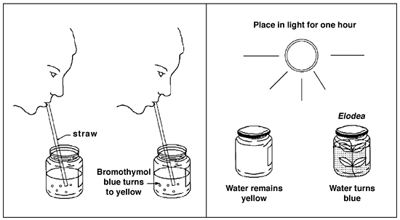

- Explain why the solution with the plant turned blue after a few hours under the light?

- If the jar with the plant above were put in the dark, what color would the solution turn and why?

- Describe how carbon is cycled through the biosphere.

- How do producers get carbon from the carbon cycle?

- How do consumers get carbon from the carbon cycle?

- What are some reservoirs (storage areas) of carbon?

- How is nitrogen cycled through the biosphere? Where are large amounts of nitrogen stored?

- Describe how water is cycled through the biosphere.

