Pedigree Charts – In class practice
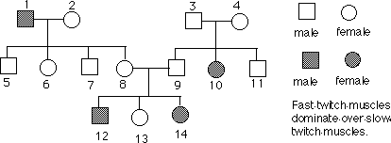

- Place the genotypes of each individual below its symbol.
- What is the genotype of individual #3 and 4?
- Can either individual #8 or 9 be homozygous?
- Explain the family relationship that #12 has with #2.

Pedigree Charts – In class practice
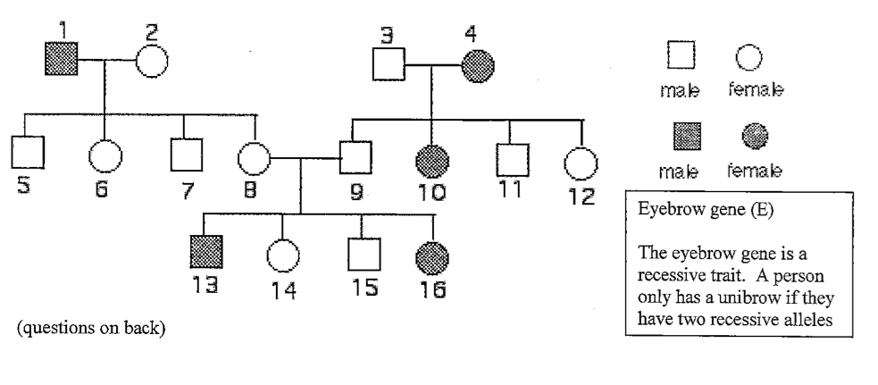
- How many family members have unibrows?
- What is the genotype of individual #4?
- Are individuals #8 and #9 homozygous or heterozygous?
- What is the genotype of individual #2?

