DNA Replication Using Paper Models

The DNA model you constructed last class represents only a short length of the DNA that is in an entire chromosome. A normal chromosome has over a million “rungs” formed by the nitrogen base pairs. In this activity, you and a partner will be demonstrating how DNA replication happens.

- What is DNA replication?
- Think back to our previous units… When does DNA replication happen?
- Why does DNA need to replicate?

Your DNA paper model should look similar to the picture below.

Before we begin, we have to supply our cell with additional nucleotides. Pick one paper model and carefully disassemble it.
The first step in DNA replication is the DNA molecule will “untwist” and “unzip.” The paper molecule is flat so we will say that it is already “untwisted.” Now it’s time to “unzip!” Carefully separate the DNA molecule where the base pairs meet. You should end up with a left and right side of your molecule.

Left Right
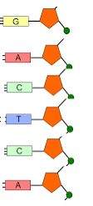
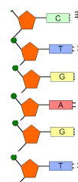

The second step in DNA replication is the addition of new nucleotides. Using the left side of you molecule as a template, add the new nucleotides. Be sure to follow the base pair rules! Then do the same for the right side of your molecule.
- Do the two new molecules of DNA contain the same number of rungs?
- Compare the two DNA molecules. Is the order of pairs from top to bottom the same or different for each molecule?
- Are the two DNA molecules exact copies of each other?
- Where in the DNA replication process could a mistake be made?

