Word Bank:

Anaphase
Cell Cycle
Cell Division
Cell Membrane
Cell Plate
Centromere
Chromosomes
Cytokinesis
DNA
G1 Phase
G2 Phase
Interphase
Prophase
Metaphase
Mitosis
S Phase
Sister Chromatid
Spindle Fibers
Telophase

Determines what food can get in a cell and what waste can get out
Holds our genetic information
Acts as a set of instructions for the cell
The process of growing, copying, and dividing
The process by which a cell divides into two new daughter cells
Where growth and duplication takes place
Includes G₁ phase, S phase, and G₂ phase
The cell grows
New proteins and organelles are synthesized
DNA synthesis takes place
Chromosomes are replicated
DNA tightly coiled around proteins
Organelles and molecules required for cell division are produced
Identical copies of the DNA
Made in the S-phase
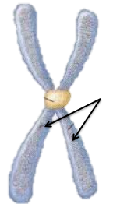
Holds two sister chromatid together
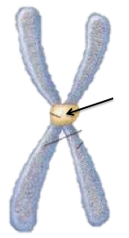
Division of the cells nucleus
Division of the cells cytoplasm
Centrioles separate
Chromatin condenses
Spindle begins to form
Nuclear envelope breaks down
Chromosomes line up in the middle
Sister chromatids separate
Chromosomes gather at opposite ends of the cell
A new nuclear envelope forms
A structure that forms in plants halfway between the divided nuclei
Helps separate the chromosomes

