 |  | Replicated homologous chromosomes pair up
 |  | Paired chromosomes, one from each parent that are almost identical
Sex cells
(Human = Eggs and Sperm)

Formed by separating homologous chromosomes to four cells with just one single chromosome
When homologous chromosomes exchange a portion of their chromatids
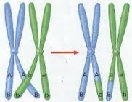
A cell that contains both sets of paired chromosomes
(2n)
A cell that contains only a single set of chromosomes
(n)
 |  | The process that makes gametes
Version of a gene
Located on chromosomes
 |  | Identical copies of chromosomes
 |  | The process by which a female gamete joins with a male gamete
Word Choices:  Fertilization  Gamete  Tetrad  Haploid  Allele |  | Crossing-over  Homologous  Diploid  Meiosis  Sister Chromatids

