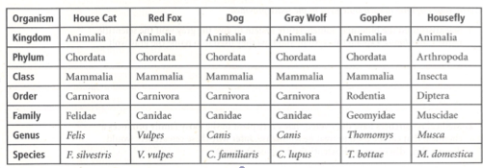

Use the table above to respond to each statement.

- Identify the scientific name for the housefly.

- Which two organisms do you think are most closely related? Why?

- Which organism is the least related to the others? Explain.

- If organisms belong to the same family, do they have to belong to the same order? If not, can they belong to the same order?

- If organisms belong to the same family, do they have to belong to the same genus? If not, can they belong to the same genus?

