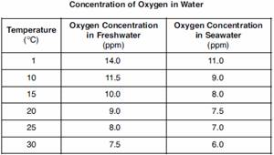

- Make a graph using the data in the above table.
- What would the oxygen concentration be in fresh water at 35 C?
- What conclusion can be made from this graph with regards to the dissolved oxygen concentration in fresh water and salt water.

Temperature (°C) | Heart Rate (bpm) Subject 1 | Heart Rate (bpm) Subject 2
5 | 110 | 120
10 | 150 | 165
15 | 200 | 200
20 | 260 | 230
25 | 300 | 270

- Make a graph using the data in the above table.
- What is the heart rate of Subject 1 at 12 °C?
- Based on this graph, what conclusions can be drawn?

