Evolution Study Guide
Vocabulary

Be able to define and understand the following words:

Evolution
Natural Selection
Trait
Variation
Adaptation
Extinction
Fitness
Resistance
Predator
Prey
Coevolution
Artificial Selection
Fossil
Autotrophs
Heterotrophs
Species
Population
Competition

- How does variation play a role in evolution?
- Where does variation come from?
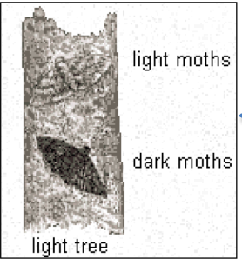
- What type of variation exists in the moth population in the picture below?
- Naturalists have observed that dark moths are eaten at a higher rate than the light moths in areas with more light trees. The opposite is true in areas with more dark trees. Which moths are most fit for a dark-tree environment? Why?

- What two things must all “fit” individuals do?
______________________________________ & ______________________________________
- Explain why the following statement is not always true:

Fitness means being big and strong.
- Give one specific example of a predator adaptation.
- Give one specific example of a prey adaptation.

- True or False? Individual organisms can adapt to their environment.
- With springtime approaching, Mr. Jones recently began gardening. As his plants grew, he discovered that there were several weedy thistles taking over his garden. He sprayed the thistles with herbicide, hoping that would solve the problem. A couple of days later, Mr. Jones noticed that the majority of the thistles had died but a couple of the thistles did not. Mr. Jones decides to try and spray the surviving thistles with the herbicide again. Explain why this will most likely not work.
- Flamingos are typically known for their pink-colored feathers. If a wildlife biologist studying the flamingo population in South America comes across a white-colored flamingo, what might he hypothesize?
  - The variation of feather color in the flamingo population has decreased
  - The number of white flamingos may increase if the trait is an advantage
  - The number of white flamingos may decrease if the trait is an advantage
  - None of the above

Read the following paragraphs and then complete the table below.
The armadillo is really strange looking. Although most armadillo species look like they have no hair, they do have wiry hairs on their sides and belly. Some people refer to the hairs as curb feelers since armadillos can feel their way around an area at night as the hairs touch objects.

The one thing that tells everyone they are looking at an armadillo is the roly-poly shell with what are called “armored” bands. The number of bands depends on the species. The pleated look of most armadillos is made of these hardened, overlapping sections. Although the bands are tough like fingernails, the shell is flexible, with softer skin that expands and contracts between the bands.
Armadillos also have long claws for digging and foraging for food. Their peg-shaped teeth crunch through the bodies of insets, an armadillo’s favorite food.
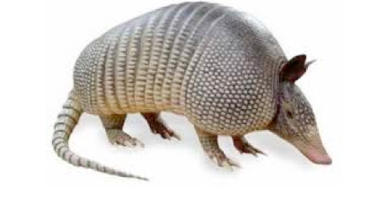

Adaptation | Why is it an adaptation?
1. | 1.
2. | 2.

Use the diagram to answer the questions below.
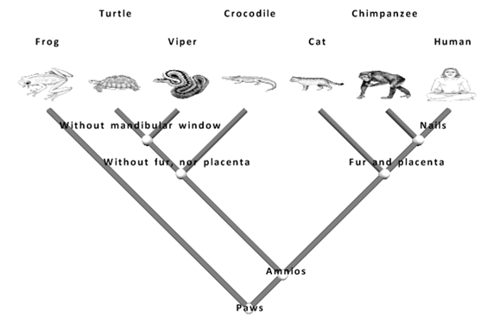
- Which two species are the least closely related?
- Who is more closely related - A turtle and a frog or a turtle and a crocodile?
- Which species are turtles the most closely related to?
- Which species are frogs the most closely related to?

