Name: __________________________

DNA & RNA Study Guide

What does DNA stand for?

What makes up a nucleotide?
What is the shape of a DNA strand?

What are the four bases of DNA? What are the base pairing rules?

Give the compliment strand for the following DNA strand:
A T C T A G T A C T A G

What are three differences & three similarities between RNA & DNA?

What is a gene?

What are the three types of RNA and their functions?

 | DNA Replication | Transcription | Translation
What is made?
What molecules are used?
Where in the cell does it take place?
What are the base pairing rules?
Fill in the table:

Transcribe the following DNA strand into an mRNA strand:
A T C T A G T A C T A G

What is a codon and an anticodon and where can they be found?

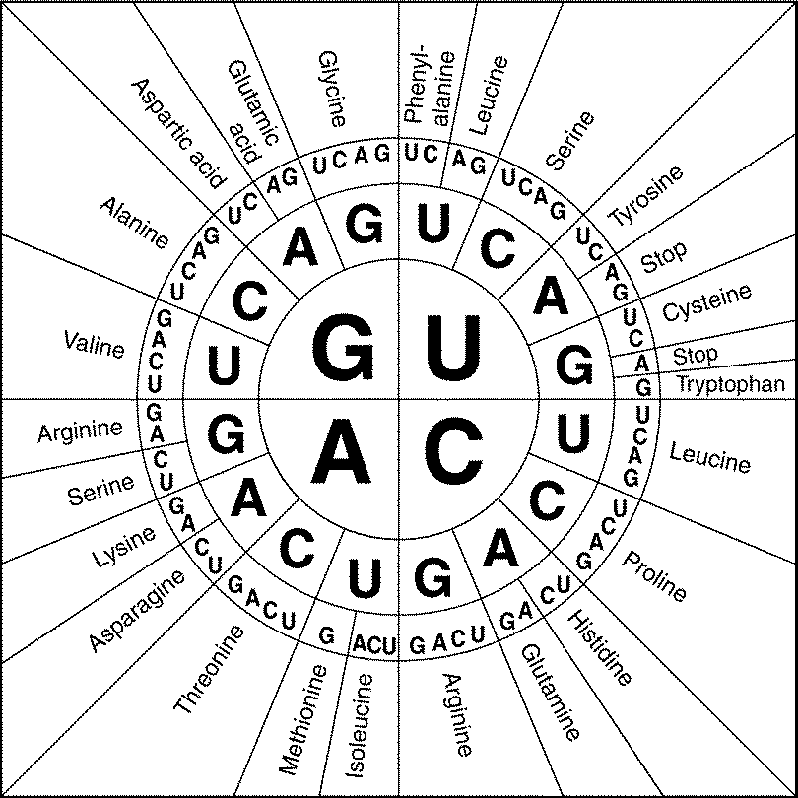
What are the two major types of mutations?

Be able to use the Codon Wheel to create a protein by
determining what amino acid is being coded for.
Example: mRNA: AUGCAGGCCGGAUGA

