Genetic Crosses that Involve 2 Traits Name: _______________________
In rabbits, grey hair is dominant to white hair. Also in rabbits, black eyes are dominant to red eyes.
GG = gray hair  Gg = gray hair  gg = white hair | BB = black eyes  Bb = black eyes  bb = red eyes
1. What are the phenotypes (descriptions) of rabbits that have the following genotypes:
Ggbb _______________________ ggBB _______________________________
ggbb ________________________ GgBb _______________________________
2. A male rabbit with the genotype GGbb is crossed with a female rabbit with the genotype ggBb The square is set up below. Fill in just the gametes below.

3. A male rabbit with the genotype GgBb is crossed with a female rabbit with the genotype GgBb The square is set up below. Fill it out and determine the phenotypes and proportions in the offspring.

How many out of 16 have grey fur and black eyes? ____
How many out of 16 have grey fur and red eyes? _____
How many out of 16 have white fur and black eyes? ____
How many out of 16 have white fur and red eyes? _____
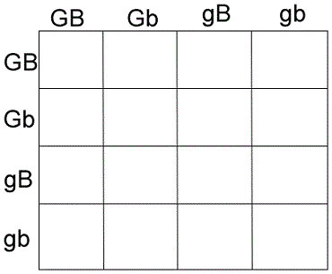

4. Show the cross between a ggBb and a GGBb.

