Cladograms

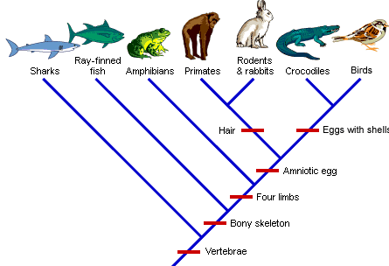

- List the traits of a crocodile.

- Which trait is only found in primates, rodents, and rabbits?

- Which animal is most closely related to a shark?

- Which animal is least closely related to a shark?

- Which animal is most closely related to primates?

- Which animals have a bony skeleton?

- Which trait do all of the organisms on the cladogram have?
Cladograms

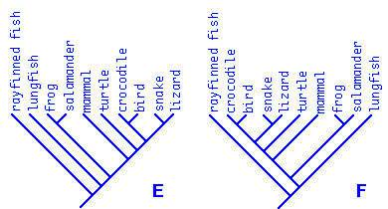

1. Which animal is most closely related to a frog?

2. Which animal is least closely related to a lungfish?

3. Who shares a more recent ancestor - crocodiles and mammals or crocodiles and
salamanders?

4. Which animal is most closely related to a ray-finned fish?

Use the information in the chart below to make a cladogram.

 | Perch | Monkey | Lizard | Mouse | Pigeon | Hagfish | Salamander
Jaws | Present | Present | Present | Present | Present | Absent | Present
Lungs | Absent | Present | Present | Present | Present | Absent | Present
Claws or Nails | Absent | Present | Present | Present | Present | Absent | Absent
Wings | Absent | Absent | Absent | Absent | Present | Absent | Absent
Mammary glands | Absent | Present | Absent | Present | Absent | Absent | Absent
Fur or feathers | Absent | Present | Absent | Present | Present | Absent | Absent
Opposable thumbs | Absent | Present | Absent | Absent | Absent | Absent | Absent

Cladogram:

1. In the cladogram you drew, which animal is least closely related to the others?

2. Which trait separates the least closely related animal from the others?

3. Which animal is most closely related to the monkey?

4. Who shares a more recent common ancestor - a mouse and a pigeon or a salamander and a hagfish?

5. Determine where a frog would fit into the cladogram and give an explanation for why it would fit there.

