Chlorophyll and the Color of Light
A pigment is a colored chemical compound that absorbs light. You can think of a pigment as a kind of sponge that absorbs light of all colors except the ones that it transmits and reflects. The colors that you see are the colors of light that the pigment reflects. The bar graph below shows the percentages of light of different colors that are reflected by the plant pigment chlorophyll.

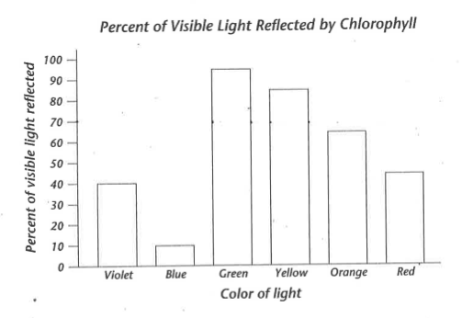
- Which color of light does chlorophyll reflect most? _____________________________________
- About what percent of light of this color does chlorophyll reflect? _____________________
- Which color of light does chlorophyll absorb most? _____________________________________
- About what percent of light of this color does chlorophyll absorb? ___________________
- The colors that are reflected less than 50% contribute very little to what the eye sees. Which colors does your eye respond to when you look at “green” leaf?
_________________________________________________________________________________________________
- Which colors of light do you not see when you look at a “green” leaf?
_________________________________________________________________________________________________
- Explain in your own words how chlorophyll makes a leaf look green.
_________________________________________________________________________________________________
_________________________________________________________________________________________________

