Calculating Surface Area to Volume Ratio

Surface Area (SA) – area of material that it would take to completely cover an object
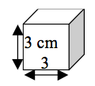
- Example – the amount of wrapping paper it would take to wrap an expensive gift for Ms. Steffen.
- Calculation for a cube-shaped object:
SA = Length x Height x Number of Sides

- For the cube pictured:
SA = 3 cm x 3 cm x 6
SA = 54 cm²
Volume (V) – the amount of space inside an object
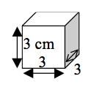
- Example – how much water would fit inside a bottle
- Calculation for a cube-shaped object:
V = Length x Height x Depth

- For the cube pictured:
V = 3 cm x 3 cm x 3 cm
V = 27 cm³
Surface Area to Volume Ratio (SA:V) – the proportion of amount of material covering an object to amount of material within the object.
- For the cube pictured:

SA:V = 54:27

- Simplify as much as possible so that V = 1. For the cube pictured, each side is divisible by 27.

SA:V = 54:27
SA:V = 54/27: 27/27
SA:V = 2:1
- What this tells you is that for every 2 units of surface area covering the outside of the cube, there is 1 unit of volume in the inside of the cube.
Practice Problems
For the four cubes below, measure the side of each cube (in cm) with a ruler. Then calculate the Surface Area, Volume, and Surface Area to Volume Ratio. Make sure to simplify the ratio so that Volume is = 1.
Cube A:

- Surface Area
- Volume
- SA:V

Cube B:

- Surface Area
- Volume
- SA:V

Cube C:

- Surface Area
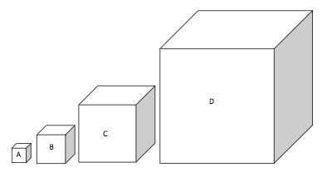
- Volume
- SA:V

Cube D:

- Surface Area
- Volume
- SA:V
Questions
- What pattern do you notice as the size of the “cells” increase?
- Why is this important to living cells?
- What can cells do to solve the problem?

