Use the chart below to write a secret message using the Codon (D) language instead of English. Your message should be short and it should involve the completion of a simple task (draw something or make something using scissors, paper, colored pencils, markers, crayons, or other supplies you would find in the classroom). Your message has to start with TAC and end with a period (CGG).

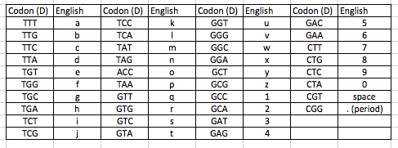

Write down the number that the teacher assigns you.

#
Message:

Coded Message:

TAC -

