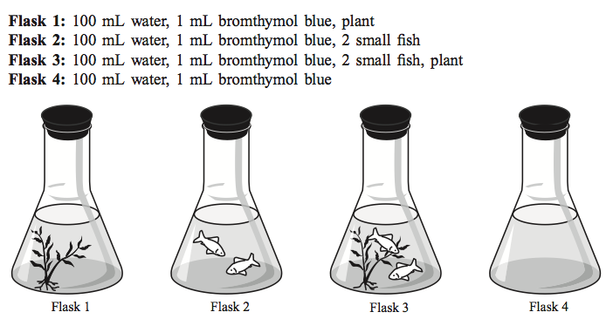

A class set up an experiment with the four flasks above. Each flask had a stopper and was put under a light. What color should the solution in each flask be?

 | Original color | Color after a few hours? | Explanation
Flask 1
Flask 2
Flask 3
Flask 4

